Early computer systems allowed only one program to be executed at a time. This program has complete control of the system and access to all the system's resources. The computer systems allow multiple programs to be loaded into memory & executed concurrently. Process is a program in execution. A system is a collection of Processes: operating-system processes executing system code and user processes executing user code. All these processes can execute concurrently with the CPU. By switching the CPU between processes.

- Process Concept:
Process is a program in execution. Process address space is organized into code, data (static/global), heap, and stack segments.
A process is more than the program code, which is sometimes known as the text section. It also includes the program counter and the contents of the processor's registers for store current values of process.
Process stack contains temporary data (such as function parameters, return addresses, and local variables).
Data section contains global variables.
Heap- which is memory that is dynamically allocated during process run time.
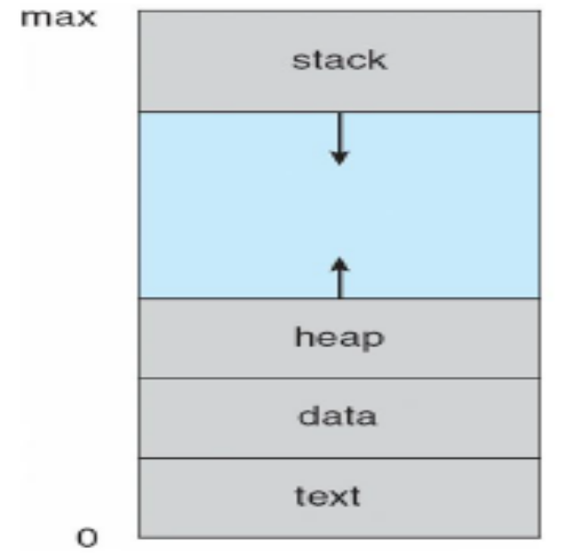
Figure: Process in memory
A program is not a process; a program is a passive entity, such as a file containing a list of instructions stored on disk (executable file), but a process is an active entity, with a program counter specifying the next instruction to execute and a set of associated resources. A program becomes a process when an executable file is loaded into memory. Although two processes may be associated with the same program, the text sections are equivalent, the data, heap, and stack sections vary.

- Process State:
A process executes it changes state. The state of a process is defined by the current activity of that process. Each process may be in one of the Following states:
- New: The process is being created.
- Running: Instructions (processes) are being executed.
- Waiting: The process is waiting for some event to occur (such as an I/O completion or
response of a signal).
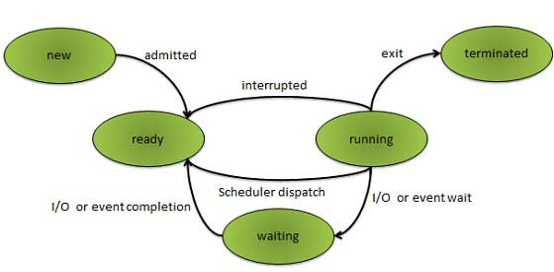

- Ready: The process is waiting to be assigned to a processor.
- Terminated: The process has finished execution.
It is important to realize that only one process can be running on a processor at a time. Although many processes may be ready and waiting of processor.

- Process Control Block:
Each process is represented in the operating system by a Process Control block (PCB) also called as Task Control Block. A PCB is shown in Figure. It contains many pieces of information associated with a specific process, including these:
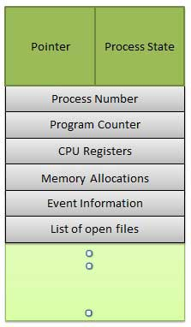
Pointer: Pointer points to another process control block. Pointer is used for maintaining the scheduling list.
Process state: The state may be new, ready running, waiting and so on.

Program counter: The counter indicates the address of the next instruction to be executed for this process.
CPU Registers: CPU registers include general purpose register, stack pointers, index registers and accumulator’s etc. number of register and type of register totally depends upon the computer architecture. Along with the program counter, this state information must be saved when an interrupt occurs, to allow the process to be continued correctly after that process to process.

CPU-scheduling information : This information includes a process priority, pointers to scheduling queues, and any other scheduling parameters.

Memory-management information : This information may include such information as the value of the base and limit registers, the page tables, or the segment tables, depending on the memory system used by the operating system.

Accounting information: This information includes the amount of CPU and real time used, time limits, account numbers, job or process numbers, and so on.

I/O status information: This information includes the list of I/O devices allocated to the process, a list of open files, and so on.
In the PCB simply serves as the repository for any information that may vary from process to process.

- Context Switch:
A context switch is the mechanism to store and restore the state or context of a CPU in Process Control block so that a process execution can be resumed from the same point at a later time. Using this technique a context switcher enables multiple processes to share a single CPU. Context switching is an essential part of a multitasking operating system features.
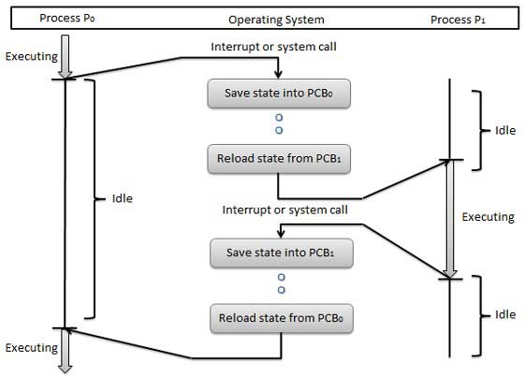
When the scheduler switches the CPU from executing one process to execute another, the context switcher saves the content of all processor registers for the process being removed from the CPU, in its process descriptor. The context of a process is represented in the process control block of a process.
Context switch time is pure overhead. Context switching can significantly affect performance as modern computers have a lot of general and status registers to be saved. Content switching times are highly dependent on hardware support.

- Threads:
A thread is a flow of execution through the process code, with its own program counter, system registers and stack. A thread is also called a light weight process. Threads improve application performance through parallelism. Threads improving performance of operating system by reducing the operating cost thread is equivalent to a classical process.
Thread example is the user cannot simultaneously type characters and run the spell checker within the same process. Modern operating systems to allow a process to have multiple threads of execution and thus to perform more than one task at a time. On a system that supports threads, the PCB is expanded to include information for each thread.
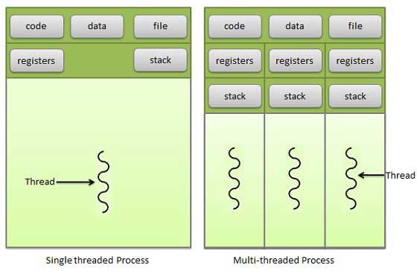

- Process Scheduling:
The objective of multi programming is process running at all times & to maximize CPU utilization. The objective of time sharing is to switch the CPU with processes so frequently that users can interact with each program while it is running. To meet these objectives, the process scheduler selects an available process for program execution on the CPU.
Processes enter in the system; they are put inside the job queue- which consists of all processes in the system. The processes that are residing in main memory and ready, waiting to execute are kept on a list called the ready queue. This queue is stored as a linked list. A ready queue header contains pointers to the first and Tail contains pointers final PCB’s in the list. Each PCB includes a pointer field that points to the next PCB in the ready queue.
The system also includes other queues. When a process is allocated the CPU, it executes for a while and eventually quits, is interrupted, or waits for the occurrence of a particular event, such as the completion of an I/0 requests.
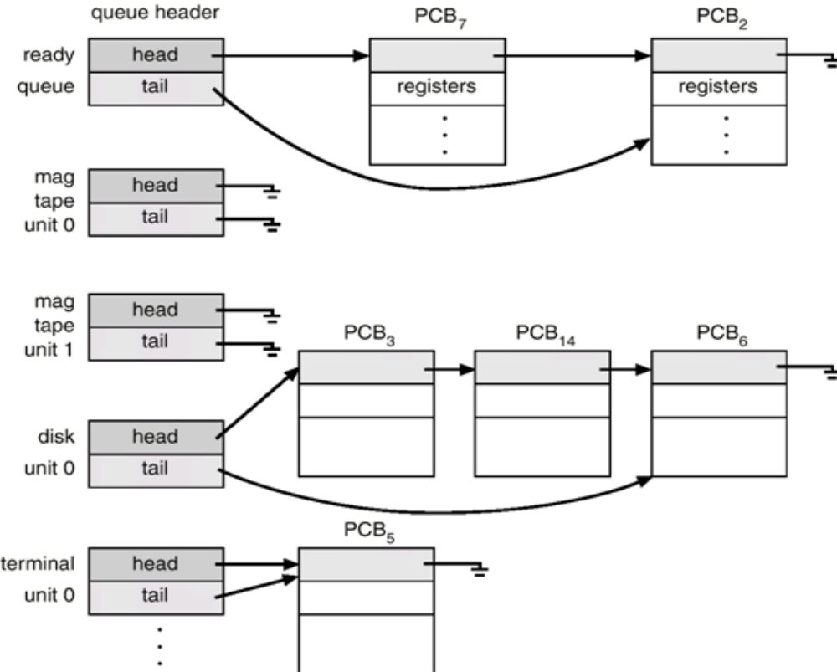
Figure A: The ready queue and various I/0 device queues.
Suppose the process makes an I/O request to a shared device, such as a disk. Since there are many processes in the system, the disk may be busy with I/O request of some other process. The process therefore may have to wait for the disk. Device queue is a queue for which multiple processes are waiting for a particular I/O device. Each device has its own device queue (Figure A). A common representation of process scheduling is a queuing diagram.
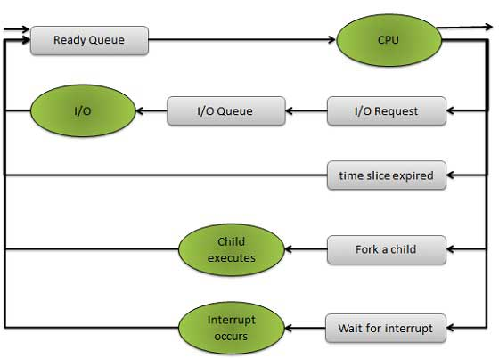
Figure B: Queuing-diagram representation of process scheduling
Such as that in Figure B. Each rectangular box represents a queue. Two types of queues are present: the ready queue and a set of device queues. The circles represent the resources that serve the queues, and the arrows indicate the flow of processes in the system. A new process is initially put in the ready queue. It waits there until it is selected for execution, or is dispatched. Once the process is allocated the CPU and is executing, one of several events could occur:
- The process could issue an I/0 request and then be placed in an I/0 queue.
- The process could create a new sub process and wait for the sub process’s termination.
- The process could be removed forcibly from the CPU, as a result of an interrupt, and be put back in the ready queue.

- Schedulers:
A process migrates among the various scheduling queues throughout its lifetime. The operating system must select for processes from these queues in some fashion scheduling purposes. The selection process is carried out by the suitable scheduler.
There are three types of Scheduler
- Long-term Scheduler, or Job Scheduler
- Short-term Scheduler, or CPU Scheduler
- Medium term Scheduler
The long-term scheduler, or job scheduler, selects processes from this pool and loads them into memory for execution. The short-term scheduler, or CPU scheduler, selects from among the processes that are ready to execute and allocates the CPU to one of them.
The primary difference between these two schedulers lies in frequency of execution. The short-term scheduler must select a new process for the CPU frequently. A process may execute for only a few milliseconds before waiting for an I/0 requests. The short-term scheduler executes at least once every 100 milliseconds. Because of the short time between executions, the short-term scheduler must be fast. If it takes 10 milliseconds to decide to execute a process for 100 milliseconds, then 10/ (100 + 10) = 9% of the CPU is being used (wasted) simply for scheduling the work.
The long-term scheduler executes much less frequently. The long-term scheduler controls the degree of multiprogramming. If the degree of multiprogramming is stable, then the average rate of process creation must be equal to the average departure rate of processes leaving the system. Thus, the long-term scheduler may need to be invoked only when a process leaves the system. Because of the longer interval between executions, the long-term scheduler can give to take more time to decide which process should be selected for execution. It is important that in long-term scheduler make a careful selection. Most processes can be described as I/0 bound or CPU bound. An I/O-bound process is one that spends more of its time doing I/O than it spends doing computations. A CPU-bound process, in contrast, generates I/0 requests infrequently, using more of its time doing computations. It is important that the long-term scheduler select a good process mix of I/O-bound and CPU-bound processes. If all processes are I/0 bound, the ready queue will almost always be empty, and the short-term scheduler will have little to do. If all processes are CPU bound, the I/0 waiting queue will be empty, devices will go unused, and again the system will be unbalanced. The system with the best performance will thus have a combination of CPU-bound and I/O-bound processes. On some systems, the long-term scheduler may be absent or minimal. For example, time-sharing systems such as UNIX and Microsoft Windows systems often have no long-term scheduler but simply put every new process in memory for the short-term scheduler. Some operating systems, such as time-sharing systems, may introduce an additional, intermediate level of scheduling. Following Figure is medium-term scheduler
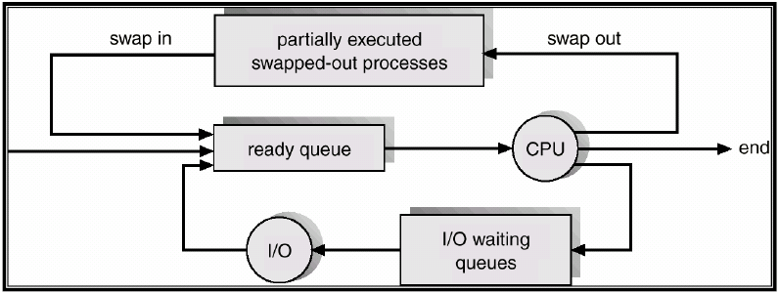
The idea behind a medium-term scheduler is that sometimes it can be beneficial to remove processes from memory and thus reduce the degree of multiprogramming. Later, the process can be reintroduced into memory, and its execution can be continued where it left off. This scheme is called swapping. The process is swapped out, and is later swapped in, by the medium-term scheduler. Swapping may be necessary to improve the process mix or because a change in memory requirements has overcommitted available memory, requiring memory to be freed up.

Long Term Scheduler | Short Term Scheduler | Medium Term Scheduler
It is a job scheduler | It is a CPU scheduler | It is a process swapping scheduler.
Speed is lesser than short term scheduler | Speed is fastest among other two | Speed is in between both short and long term scheduler.
It controls the degree of multiprogramming | It provides lesser control over degree of multiprogramming | It reduces the degree of multiprogramming.
It is almost absent or minimal in time sharing system | It is also minimal in time sharing system | It is a part of Time sharing systems.
It selects processes from pool and loads them into memory for execution | It selects those processes which are ready to execute | It can re-introduce the process into memory and execution can be continued.

- Operations on Processes:
The processes mostly execute concurrently, and they may be created and deleted dynamically. Thus, these systems must provide a mechanism for process creation and termination.
Process Creations:
A process can create new processes during its execution. Process which creates another process is called a parent process; the created process is called a child process resulting in a tree of processes. Generally a process is identified and managed by a process identifier (pid). When a process creates a subprocess, that subprocess can obtain resources from the OS directly or it may be constrained to a subset of the parent process resources. Restricting a child process to a subset of the parent's resources prevents any process from overloading the system by creating too many subprocesses.
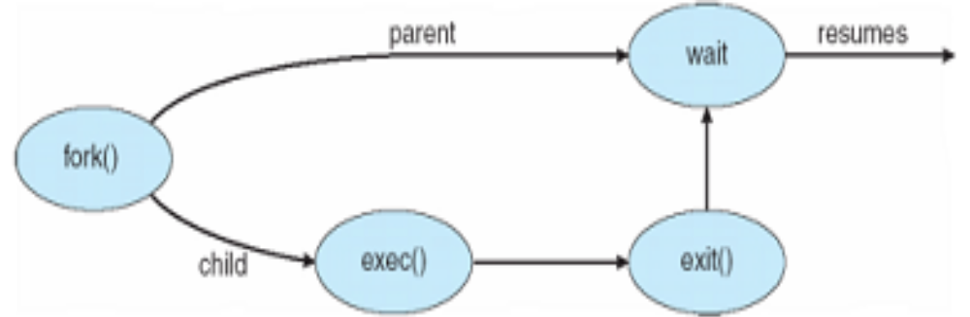
When a process creates a new process, two possibilities exist in terms of execution:
- The parent continues to execute concurrently with its children.
- The parent waits until some or all of its children have terminated.
There are also two possibilities in terms of the address space of the new process:
- The child process is a duplicate of the parent process (it has the same program and data as the parent).
- The child process has a new program loaded into it.
When one process creates a new process, the identity of the newly created process is passed to the parent so that a parent knows the identities of all its children.
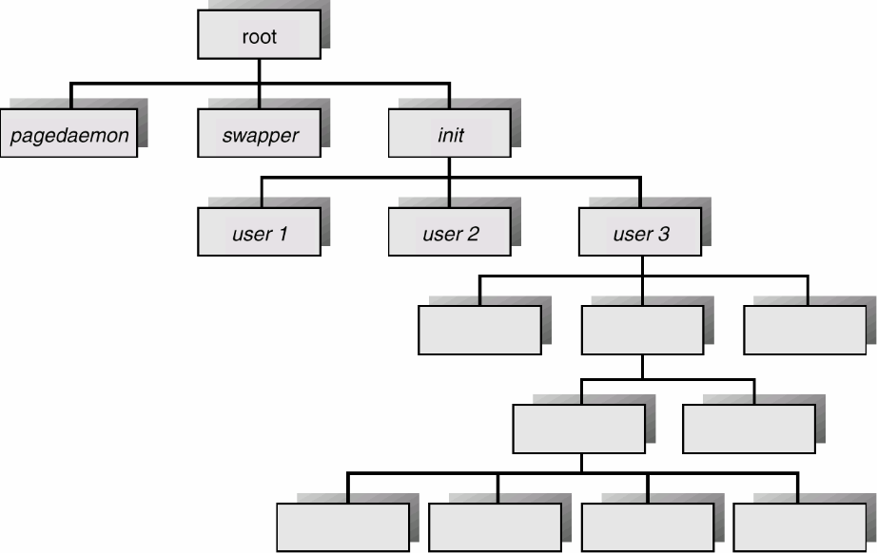
In UNIX, a new process is created by the fork system call. The new process consists of a copy of the address space of the original process. This mechanism allows the parent process to communicate easily with its child process. Both processes (the parent and the child) continue execution at the instruction after the fork system call, with one difference: The return code for the fork system call is zero for the new (child) process, whereas the (nonzero) process identifier of the child is returned to the parent.

Process Termination:
A process terminates when it finishes executing its final statement and asks the operating system to delete it by using the exit system call. The child process may return data (output) to the parent process. All the resources of the process-including physical and virtual memory, open files, and I/0 buffers-are deallocated by the operating system.
A parent may terminate the execution of one of its children for a variety of reasons, such as:
- The child has exceeded its usage of some of the resources that it has been allocated.
- The task assigned to the child is no longer required.
- The parent is exiting, and the operating system does not allow a child to continue if its parent terminates. On such systems, if a process terminates (either normally or abnormally), then all its children must also be terminated. This referred to as cascading termination, is normally initiated by the operating system.

- Cooperating Process:
Processes executing concurrently in the operating system may be either independent processes or cooperating processes. A process is independent if it cannot affect or be affected by the other processes executing in the system. Any process that does not share data with any other process is independent. A process is cooperating if it can affect or be affected by the other processes executing in the system. Clearly, any process that shares data with other processes is a cooperating process. There are several reasons for providing an environment that allows process cooperation:
Information sharing: several users may be interested in the same piece of information; we must provide an environment to allow concurrent access to such information.
Computation speedup: If we want a particular task to run faster, we must break it into subtasks, each of which will be executing in parallel with the others. Notice that such a speedup can be achieved only if the computer has multiple processing elements (such as CPUs or I/O channels).
Modularity: We may want to construct the system in a modular fashion, dividing the system functions into separate processes or threads.
Convenience: Even an individual user may work on many tasks at the same time. For instance, a user may be editing, printing, and compiling in parallel.
Cooperating processes require an interprocess communication (IPC) mechanism that will allow them to exchange data and information. There are two fundamental models of interprocess communication: (1) shared memory and (2) message passing.
In the shared-memory model, a region of memory that is shared by cooperating processes is established. Processes can then exchange information by reading and writing data to the shared region. In the message-passing model, communication takes place by means of messages exchanged between the cooperating processes. The two communications models are Figure. Both of the models just discussed are common in operating systems, and many systems implement both. Message passing is useful for exchanging smaller amounts of data, because no conflicts need be avoided. Message passing is also easier to implement than is shared memory for inter computer communication. Shared memory allows maximum speed and convenience of communication. Shared memory is faster than message passing, as message-passing systems are typically implemented using system calls and thus require the more time-consuming task of kernel intervention. In contrast, in shared-memory systems, system calls are required only to establish shared-memory regions. Once shared memory is established, all accesses are treated as routine memory accesses, and no assistance from the kernel is required.
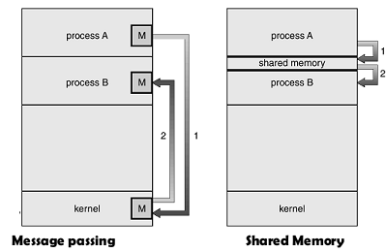

Process | Thread
Process is heavy weight or resource intensive. | Thread is light weight taking lesser resources than a process.
Process switching needs interaction with operating system. | Thread switching does not need to interact with operating system.
In multiple processing environments each process executes the same code but has its own memory and file resources. | All threads can share same set of open files, child processes.
If one process is blocked then no other process can execute until the first process is unblocked. | While one thread is blocked and waiting, second thread in the same task can run.
Multiple processes without using threads use more resources. | Multiple threaded processes use fewer resources.
In multiple processes each process operates independently of the others. | One thread can read, write or change another thread's data.

Q1. Define process. Briefly describe the various states a process can have? Also discuss the state transition diagram.
Q2. Write a short note on Process Control Block (PCB) by explaining its utility in process management.
Q3. List at least 4 reasons for process termination. Also discuss the need for the suspend state?
Q4. What are schedulers? Discuss the various types of schedulers & Difference?
Q5. Explain the concept of context switch.
Q6. Define a thread. Compare with process.
Q7. Explain different Process scheduling.
Q8. Explain the operations on process?
Q9. Explain the cooperating processes?

